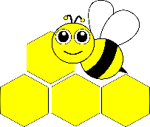
Busy Bee Quilters Presents their
2019 Quilt Show:
“Fresh & New” beeutiful quilts

Sept 13-14, 2019 10:00 – 5:00
both days
Hope Church
5002 Bickford Ave
Snohomish, WA

Admission: Donation of $3 or 3 cans of food for the Snohomish Food Bank.
16 & under are free!
Merchant MallTea RoomOver 200 quilts

Featured Artist: Linda Dills 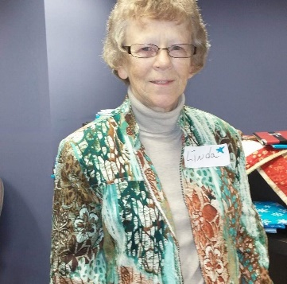

My mother and paternal grandmother were quilters. So there have been hand-made quilts on my beds my whole life. As a child I enjoyed looking at those quilts and picking out the fabrics that had been scraps from dresses that my Mother had made for me. I helped my Mother tie quilts at a very young age. I learned hand embroidery about 10 years of age. The first clothing experience came in high school. My first quilt was made in 1973. It was polyester knit and raw edge applique. For the next 15 years I made a few baby quilts for gifts but work and family took most of my time.
In 1988 I discovered free motion thread painting and a group called The Machine Embroiders of Oregon and Washington. I met a few quilters who were members of this group and in 2001, I joined Busy Bees. I was the doll quilt chairman for 3 years and have always enjoyed helping with the quilt shows.
My first quilt show was 2002 and have been entering local guild shows in eastern and western Washington every year. Realistic pictorials are my favorite. My ideas come from stained glass patterns, enlarged counted cross stitch patterns and Dover coloring books are a great source for realistic animals and plants. I have made appliqued birds from the petals of silk flowers. The ideas are endless. I enjoy experimenting with new techniques, such as fabric dying, painting on fabric also using paint sticks, and colored pencils. The best part of the quilting world is the people I have met and the friends I have made.

